Self-Evaluation: International Experience at School
Prepare to analyze your experience while you are abroad and upon your return.

Write your name and date here.

Think Analytically About Going Abroad
Do you have the drive to be a cross-cultural communicator, and an internationally oriented professional? Do you have the motivation to learn about foreign cultures, build language skills and become a truly “global” thinker?
Are you already involved in international activities on your home campus? If the answer to any of these questions is yes, it’s time to start writing about your skills and experiences.

3

Writing Tips  - Even if writing isn't your thing, jotting down a few notes about your adventures can really boost what you get out of your travels. It's a simple way to learn more and make your journey even more valuable!  - Move beyond simple enthusiasm and basic anecdotes (“The Taj Mahal was incredible!”)!  - Maximize the professional value of your international experience by thinking more deeply about your experiences.  - Incorporate an analytical perspective as opposed to simply recounting your experiences. | - Write as if you were speaking to a employer, a mentor or a professor.  - Show your knowledge, skills and attitude.  - Develop career stories: Ask yourself what specific interactions with locals gave you insights into the culture and allowed you to build valuable skills like adaptability?  - Demonstrate your insights in terms of global competencies & career readiness as well as intercultural interactions.

16 Questions to Get You Thinking
Analytically About Your Experience
Questions | Your Answers
- What drives you to be an internationally-oriented student? | Write your notes here.
- Do you have an international interest in a particular subject area, language, or region of the world? If so, why? | Write your notes here.
- How have you geared your classes or study path to incorporate your international interests? | Write your notes here.
- How do you keep up with international news and/or stay connected globally? | Write your notes here.
- What internationally-focused activities have you taken part in on campus and why are you attracted to these activities? | Write your notes here.
- you participate in international clubs and what do you enjoy about them? | Write your notes here.
- Have you connected with international students on campus? If so, what have you learned from these connections? | Write your notes here.
- Have you connected with internationally-oriented faculty members? How have they helped you expand your international understanding, focus your goals, or gain more experience? | Write your notes here.
- Have you benefited from services in the study abroad or career offices; and how have they helped with your international aspirations? | Write your notes here.
- Please describe what makes you successful as a globally-minded student. | Write your notes here.
- Do you have a classroom story that gave you particular insight into other cultures? | Write your notes here.
- Have you participated in any off-campus activities that have helped you build your cross-cultural understanding and skills? | Write your notes here.
- Have you been abroad? When, where, and why did you go? What impression did your trip make on you? | Write your notes here.
- Describe an “international experience“ at home or abroad that made a particularly strong impression on you. | Write your notes here.
- Do you have advice for anyone hoping to build international skills on campus? | Write your notes here.
- What are your future plans for going abroad, building your language skills, and for your career? | Write your notes here.

Energize Your Self-Evaluation
When you first head abroad, it’s energizing to get caught up in the excitement of the moment. | You’ll be in a state of high energy with so much stimulation around you, breathing in the wondrous air of your new home. You’ll be speed learning as you figure out how best to communicate across cultures, how to behave and how to get around. It’s easy to let this time fly by without stopping to reflect on your experiences – but don’t miss the chance to harness this energy and write about your impressions of life abroad! Not only will your writing be interesting to read when your adventure comes to an end; it will also give you unique insights into your personal and professional skill development.  By writing, you’ll be reflecting on your experiences from a different perspective, and you’ll surely find new and interesting ways of understanding your process of cultural immersion. | By thinking and making notes about your time abroad, you’ll also be building a professional profile of yourself in this new cross-cultural environment.  You’ll be able to observe yourself as you grow into an effective communicator and culture-savvy young professional.  So, pick up a pen, or flip open your laptop and start writing as soon as you plan to go abroad. We recommend writing in a professional, thoughtful tone. This will allow you to easily transfer your writings into an interview or on-the-job context. MyWorldAbroad has compiled a selection of questions that will help you focus your writing and prepare you for the moment when a potential employer asks you about your time abroad.

Don't Forget  the Visuals!  Also, when you go abroad, be sure to document them with photographs and/or videos. Collect photos that showcase or highlight your interactions with locals, rather than simply collecting standard sight-seeing photos. When you do take a sight-seeing photo, make sure you’re in it! Photos without people can be boring, and they don't highlight your personal involvement. | Submit Your  Story from Abroad  If you are an internationally minded student or young professional with cross-cultural travel experience, why not submit your answers to the questions above as a Story from Abroad to MyWorldAbroad? Here at MyWorldAbroad, we are eager to highlight exceptional student stories! Your story will be professionally edited so that you will shine and look your professional best. Access the submissions page here (and receive a $50 gift card).  We’d love to hear from you!

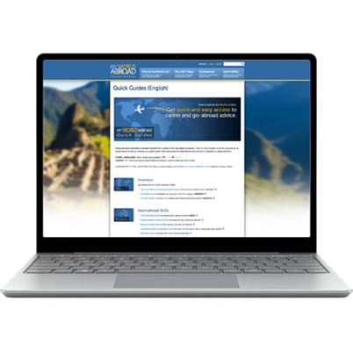 | Your free subscription paid for by your school.

