Self-Evaluation: Teaching English Abroad
Prepare to analyze your experience while you are abroad and upon your return.

Write your name and date here.

Think Analytically About Going Abroad
Teaching English abroad is an experience unlike any other. It puts you immediately in a professional context, interacting with locals of all ages in your
host country.
From the moment you arrive, you'll find yourself having insights into your host country, cross-cultural communication techniques, methods for adapting to foreign environments and, likely, insights into your own growth as a global citizen. These insights will only become richer and more layered as time passes. Writing your thoughts down will allow you to make a document of the dynamic changes that take place in your International IQ and outlook on your host culture and the world.

3

Writing Tips  - Even if writing isn't your thing, jotting down a few notes about your adventures can really boost what you get out of your travels. It's a simple way to learn more and make your journey even more valuable!  - Move beyond simple enthusiasm and basic anecdotes (“The Taj Mahal was incredible!”)!  - Maximize the professional value of your international experience by thinking more deeply about your experiences.  - Incorporate an analytical perspective as opposed to simply recounting your experiences. | - Write as if you were speaking to a employer, a mentor or a professor.  - Show your knowledge, skills and attitude.  - Develop career stories: Ask yourself what specific interactions with locals gave you insights into the culture and allowed you to build valuable skills like adaptability?  - Demonstrate your insights in terms of global competencies & career readiness as well as intercultural interactions.

17 Questions to Get You Thinking
Analytically About Your Experience
Questions | Your Answers
- When and where are you teaching or did you teach abroad? Did you go with a program? | Write your notes here.
- What made you want to teach English abroad? | Write your notes here.
- How did you conduct your search? How did you select your program/country and/or find an employer abroad? | Write your notes here.
- Describe the application process. What made you successful? | Write your notes here.
- What was the biggest surprise about your teaching experience abroad? | Write your notes here.
- Did you participate in extra-curricular or social activities while abroad? If so, how did they differ from social activities in your home culture? | Write your notes here.
- What made your experience abroad a success? | Write your notes here.
- How did you finance your trip abroad and did you find any creative solutions to stay on budget? | Write your notes here.
- Do you have a story from your workplace that gave you particular insight into your host culture? | Write your notes here.
- How did you deal with the cultural divide during your time teaching abroad? | Write your notes here.
- What was the most important thing you learned about communicating in a foreign culture while you were abroad? | Write your notes here.
- What is your number one tip for anyone hoping to follow in your footsteps? | Write your notes here.
- Do you have advice on how to handle a cross-cultural classroom? | Write your notes here.
- What did you miss most about home? | Write your notes here.
- Do you have any final observations on your experience? | Write your notes here.
- Describe an experience from your time abroad that made a particularly strong impression on you. | Write your notes here.
- What are your future plans for going abroad and for your career? | Write your notes here.

Energize Your Self-Evaluation

When you first head abroad, it’s energizing to get caught up in the excitement of the moment. | You’ll be in a state of high energy with so much stimulation around you, breathing in the wondrous air of your new home. You’ll be speed learning as you figure out how best to communicate across cultures, how to behave and how to get around. It’s easy to let this time fly by without stopping to reflect on your experiences – but don’t miss the chance to harness this energy and write about your impressions of life abroad! Not only will your writing be interesting to read when your adventure comes to an end; it will also give you unique insights into your personal and professional skill development.  By writing, you’ll be reflecting on your experiences from a different perspective, and you’ll surely find new and interesting ways of understanding your process of cultural immersion. |  | By thinking and making notes about your time abroad, you’ll also be building a professional profile of yourself in this new cross-cultural environment.  You’ll be able to observe yourself as you grow into an effective communicator and culture-savvy young professional.  So, pick up a pen, or flip open your laptop and start writing as soon as you plan to go abroad. We recommend writing in a professional, thoughtful tone. This will allow you to easily transfer your writings into an interview or on-the-job context. MyWorldAbroad has compiled a selection of questions that will help you focus your writing and prepare you for the moment when a potential employer asks you about your time abroad.
Don't Forget  the Visuals!  Also, when you go abroad, be sure to document them with photographs and/or videos. Collect photos that showcase or highlight your interactions with locals, rather than simply collecting standard sight-seeing photos. When you do take a sight-seeing photo, make sure you’re in it! Photos without people can be boring, and they don't highlight your personal involvement. |  | Submit Your  Story from Abroad  If you are an internationally minded student or young professional with cross-cultural travel experience, why not submit your answers to the questions above as a Story from Abroad to MyWorldAbroad? Here at MyWorldAbroad, we are eager to highlight exceptional student stories! Your story will be professionally edited so that you will shine and look your professional best. Access the submissions page here (and receive a $50 gift card).  We’d love to hear from you!

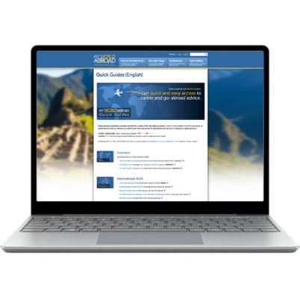 | Your free subscription paid for by your school.

